PRESS RELEASE

**

**MADRID**

**19/23.02 2014**

**Padiglione 9 / Stand 9 G 12**

***Negative Capability – Paintings***

**Carla Accardi, Pier Paolo Calzolari, Shaun Gladwell, Peter Halley, Vik Muniz, Giulio Paolini, Luca Pozzi, David Shaw**

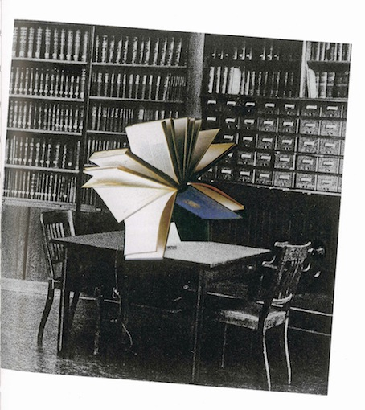

**Giulio Paolini,** *Senza titolo (Rendez vous)*, 2010, collage su carta, cm 40 x 50

Galleria Enrico Astuni is pleased to announce its participation at Arco - International contemporary Art Fair, which will take place in Madrid from the 19th to 27th February 2014.

We will be glad to welcome you at our booth (Hall 9 / Stand 9 G 12) with the project *Negative Capability - Paintings*.

The projecthas the aim to continue the investigation on the concept of “negative capability”, started with *Negative Capability – Paintings* exhibition, curated by Giovanni Iovane and Lorenzo Bruni for Galleria Astuni in 2013, and developed with the publication of critical essays book, published by Silvana Editoriale.

This first stage of the project was marked with the noun "Paintings". The painting was thus the first field of critic investigation through works by international artists of different generations.

Involving and comparing 8 international artists of different generations, *Negative Capability-Paintings* project for Arco Madridcarries on the strong theoretical reflection on the concept of "negative dialectics" -expressed almost two hundred years ago by the English poet John Keats – and identifies some of the most significant art practices, putting a renewed focus on the role, place, and the function of the artwork.

At the Feria de Madrid the exploration on the "negative capability" is extended and includes - in addition to the artists Carla Accardi, Pier Paolo Calzolari, Peter Halley, Giulio Paolini - Shaun Gladwell, Vik Muniz, Luca Pozzi and David Shaw.

**ARCO MADRID. International contemporary Art Fair**

19/23.02 2014, Halls 7 & 9, Feria de Madrid

Preview by invitation only:

19-20. 02  2014 from 12am - 9pm

Opening hours:

21/22/23. 02 2014 from 12 am - 20 pm

Entrance and parking:  Feria de Madrid