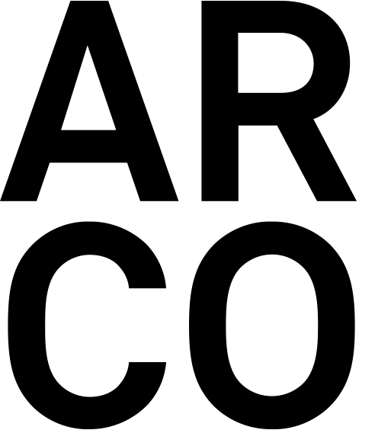

**BOOTH PREVIEW**

ØYSTEIN AASAN

CHRISTIAN JANKOWSKI

DAVID MEDALLA

MAURIZIO MOCHETTI

MAURIZIO NANNUCCI

GIANNI PIACENTINO

Galleria Enrico Astuni’s project for Arco 2023 is a group exhibition involving six internationally recognized artists: **Øystein Aasan** (1977, Kristiansand, Norway; lives and works in Berlin); **Christian Jankowski** (1968, Göttingen, Germany; lives and works in Berlin); **David Medalla** (1938 – 2020, Manila); **Maurizio Mochetti** (1940, Rome; lives and works in Rome); **Maurizio Nannucci** (1939, Florence; lives and works in Florence) and **Gianni Piacentino** (1945, Coazze, Turin; lives and works in Turin).

**The project offers a glimpse of the various directions the artists have taken over time, but also give a clear sense of them working method characterized by an enormous flair for experimenting.**

**ØYSTEIN AASAN**

Kristiansand, Norway,1977. Lives and works in Berlin

Trained at the National Collage of Art and Design, Oslo, **Øystein Aasan** in his practice uses architecture, collage, sculpture and painting to address memory, the function of images and the role of the viewer. Internationally recognised, he has exhibited in solo and group exhibitions at museums, institutions and galleries since 2003.

His recent solo and duo exhibitions and venues include the shows at LNM, Oslo (2022); *True-False Stories. The Museum as a site of interpretation*, with Paolo Chiasera, Musée d’ Art Contemporaine Sion, Musée de Bagnes, Musée du Loetschental, Musée valaisan de la Vigne et du Vin, Switzerland (2019); L40 | Kunstverein am Rosa–Luxemburg–Platz, Berlino (2019); Kristiansand Kunsthall (2018); Kunstverein Arnsberg, Arnsberg, Germania (2017).

Recent group shows include *Quattro Idee,* Galleria Enrico Astuni (2021); *Stasi Frenetica,* GAM - Galleria d’Arte Moderna di Torino (2020); *Minimalism?*, Blomqvist, Oslo (2019); *Three little maids from school,* QB Gallery, Oslo (2019); *Mies in Berlin*, Kunstverein Rosa-Luxemburg Verein (2018); *Randi Thommessen’s samling,* Rake, Trondheim, Norway (2018); *Det felles Eide*, Kunstnernes Hus, Oslo (2018); *Norsk Minimalisme?*, Blomqvist, Oslo (2018); Chateau Grillemont, Indre et Loire (2017).

His works can be found in public collections such as Sørlandets Art Museum, Norway; The National Museum of Arts, Norway; City of Oslo Public Collection; ICART, Oslo; KpA, Oslo; Collection Yoko Ono, New York; Norwegian Labour Party, Oslo.

He has published texts and essays in several international magazines, among them the Norwegian Architectural Yearbook (2016).

**Among the works on display in the booth**

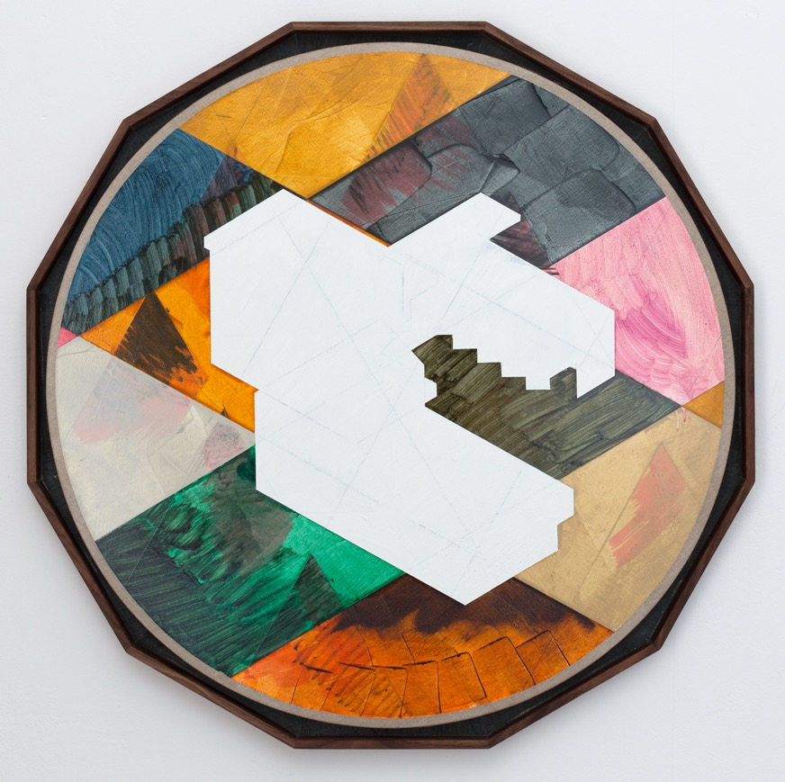

**Øystein Aasan**

*ONCE REMOVED (BASIC), The time in my charge*, 2022

Oil and oilstick on canvas, wooden, artistic frames

Ø 75 cm

*“****Once removed*** is a body of works that includes groups of paintings, paperworks and a set of small wooden models with customised displays and storage units. The overall group of works takes memories of military installations, bunkers, and similar designs as a starting point to generate a set of ideas that renders every object equal, no matter when or where it was built, no matter under what auspices it was constructed, or under what ideology. It is a set of ideas that takes an impenetrable structure and makes it flexible and indefinitely repetitive, across time, ideology, and space”. Ø.A.

*Partial view of Galleria Enrico Astuni booth at Arte Fiera 2022*

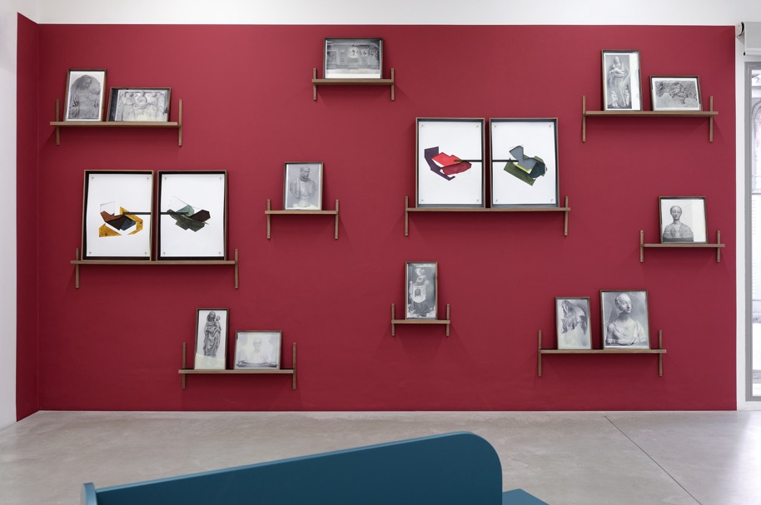

*Partial view of the exhibition QUATTRO IDEE. Øystein Aasan, Peter Halley, Jonathan Monk, Maurizio Nannucci,*a cura di Lorenzo Bruni, galleria Enrico Astuni, Bologna, 2021.*Lost series,* 2019;*Once Removed, no.1 - no.2,* 2020.

**Øystein Aasan**

*LOST series*, 2019

Photographic prints under beeswax, wooden artistic frames

Variable sizes

***LOST series*** is a project that ties in artist’s existing concerns about loss and memory. The core of the project is a series of black and white photographs that depicts artworks lost or damaged in World War II.

Aasan interest in this topic originates in a lecture and essay by W.G. Sebald *On the Natural History of Destruction*. Rather obviously, huge amounts of paintings, sculpture and architecture has been destroyed or lost in every war, and WWII saw a level of destruction unforeseen up to that point.

“My research into what was lost coincided with re-reading “Bunker Archeology” by Paul Virilio, where he describes the various “strata” of war, from subterranean to the air, and how the two world wars extended its reach onto new territories. That extension consequently included numerous artworks. My takeaway from this material was a sense of an alternative art history, attempting to imagine to what extent the contemporary could have changed if all these works still existed. So I decided to make a body of works that attempted to preserve these works again, albeit symbolically.

The photographs are preserved in beeswax, a type of material with a long connotation associated with preservation and safekeeping". Ø.A.

**Øystein Aasan**

*ONCE REMOVED no.2,* 2020

Diptychs composed of panels with 6 Ink drawings each, wooden artistic frames

71, 5 x 54, 5 cm each panel

*“****Once removed*** came to be from a number of different impulses and as such mirrors the work itself, including faint thoughts like Paul Celan’s double-words, my own vague memories or the excessive use of geolocations while searching for images. But most importantly it grew out of an existing interest and out of the works I was already making, an essay I wrote on ruins while staying in a chateau in France, a general interest in how a context surrounding an object might be changed or manipulated and a deep concern for manifestations of collective memory in the public realm”. Ø.A.

**CHRISTIAN JANKOWSKI**

Göttingen, Germany, 1968; Lives and works in Berlin

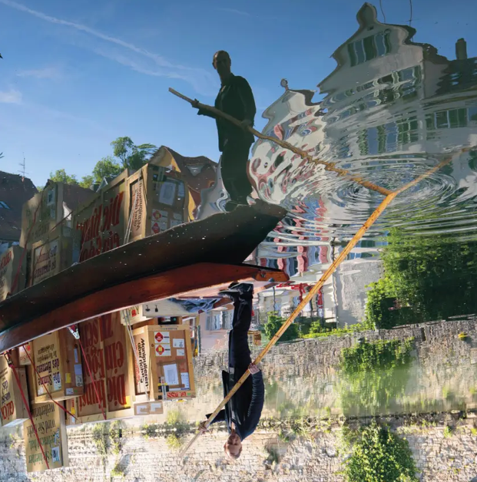

**Christian Jankowski** works in conceptual and performance art with a focus on video and photography, but also makes use of a wide range of other media, such as painting, sculpture and drawing. Artist’s unconventional working method involves surprising forms of collaboration with people outside the art world. Jankowski's work initiates collaborations between contemporary visual art and other professional worlds such as the world of religion, business, politics and entertainment. The protagonists of today's society inscribe themselves in Jankowski's art and leave their skills, their views and their aesthetics. The work is carried out in close exchange with mass media formats and their production mechanisms. The focus lies on the collective invention and the questioning of its power: Testing the image. Through the presence of multiple authors, these works of art often speak at the same time to different groups of audiences.

Jankowski's works are included in many public and private collections. Besides many group exhibitions, the artist had several solo exhibitions like I WAS TOLD TO GO WITH THE FLOW, Kunsthalle Tübingen, Tübingen (2022); *Healing Games, for Quote-Unquote*, Suprainfinit Gallery, Bucharest, Romania (2020); *Sender and Receiver,* Fluentum, Berlin (2020); *Weather Flag*, joségarcía, mx, Mérida, Mexiko, (2020); *Christian Jankowski.* *Where do we go from here?* Galleria Enrico Astuni (2019); *Floating World*, @KCUA, Kyoto (2018).

In 1999 and 2013 Jankowski participated in the Biennale di Venezia. His works were presented at the Berlin Biennale in 2001, at The Whitney Biennial in 2002 and at The Taipei Biennial in 2010. In 2016 he curated the 11th edition of Manifesta, becoming the first artist to assume this role. In 2017 Jankowski was featured at the 6th edition of The Yokohama Triennale.

Since 2005, Jankowski holds a full-time professorship at the State Academy of Fine Arts in Stuttgart.

**Among the works on display in the booth**

**Christian Jankowski**

*Chinese Whispers – Neue Malerei (Van Gogh I-X),* 2015

10 oil paintings on canvas

Various sizes

For ***Chinese Whispers – Neue Malerei (Van Gogh I-X)****,* 2015, Jankowski found photos on the internet of people re-enacting a Van Gogh portrait, sending them to China to be painted by an artist there. In this process, Van Gogh’s work is reproduced in different media, undergoing a diverse series of transformations: from the original to a re-enactment to a photograph to mass media and back to an oil painting. Van Gogh himself sometimes copied the work of other artists in a highly individual way: ‘it’s a hard and fast rule that only the composer plays his own compositions’, he wrote (letter 805, c. 20 September 1889). When the photographs, found on the internet, did not follow the dimensions of Van Gogh’s original paintings, Jankowski corrected this difference in his series by adding a part of unpainted canvas to the new composition.

**DAVID MEDALLA**

Manila, 1938 – Manila, 2020

**David Medalla**, "Poet of Art" and a pillar of international art for the past 60 years has been a pioneer of Kinetic art, Land Art, Participatory Art and Live Art. All his works arise from the dialogue of two parts: the personal experience and the collective experience.

At the age of 12 Medalla was admitted as a special student at Colombia University in New York upon the recommendation of American poet Mark van Doren. In New York City David met the American actor James Dean and the Filipino poet José Garcia Villa, who encouraged Medalla's early interest in painting. Thanks to his brilliant educational path, Medalla will be recognised by the international cultural community firstly as a poet, then as a visual artist. When he returned to Manila in the late fifties, he met the Catalan poet Jaime Gil de Biedma and the painter Fernando Zobel de Ayala, who became the earliest patrons of Medalla's art. In Paris in 1960, the French philosopher Gaston Bachelard introduced David's first performance in France at the Academy of Raymond Duncan, brother of the great American dancer Isadora Duncan. Years later in Paris, the French poet Louis Aragon (co-founder of Surrealism with André Breton) introduced another performance by Medalla and hailed him as a genius. Marcel Duchamp honoured him with a "medallic" object.

David Medalla and Mondrian Fan Club were among the invited artists at the 57. Art Biennale of Venice, *Viva Arte Viva*, curated by Christine Macel (2017).

Among his most recent solo exhibitions are *David Medalla: Parables of Friendship*, Museion, Bolzano - Bonner Kunstverein, Bonn (2022) in collaboration with David Medalla Archive, Berlin; *Locus Solus. Omaggio ad Arthur Rimbaud*, Galleria Enrico Astuni, Bologna; *Light To Night | A Stitch In Time,* National Gallery Singapore, Singapore; Among his most recent group exhibitions are Come una falena alla fiamma (Like a Moth to a Flame), Officine Grandi Riparazioni, Turin; Fondazione Sandretto Re Rebaudengo, Turin (2017); *If on a Trondheim’s night a traveler...*, works from Collezione Sandretto Re Rebaudengo, Trondheim Kunstmuseum, Norway (2017).

**Among the works on display in the booth**

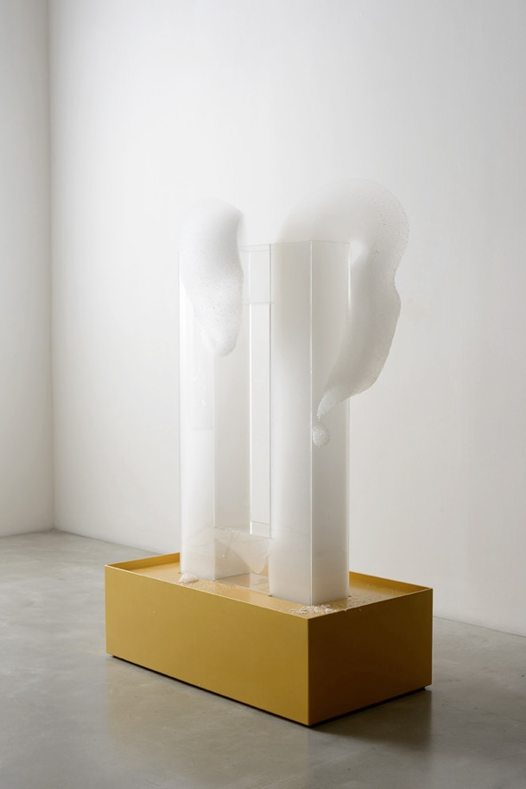

**David Medalla**

*Cloud Canyons (Bubble machines auto-creative sculptures),* 2017

Gold lacquered marine mahogany wood, plexiglas, aquarium oxygenator,

soap and water, cm h 148 x 94 x 55

***Cloud Canyons (Bubble machines auto-creative sculptures***is a reflection on the monochrome, the white, the spirituality of Suprematist painting, and the elimination of the distance between physical and mental space. By choosing a medium that self-destructs, the artist challenges the parameters of traditional sculpture, such as that of solidity and permanence, and evokes in the viewer the wonder of expectation and the epiphany of the event, in dialogue with the material and its vitality. As every Medalla’s artwork is rooted in personal experience and memories of indelible images, the idea for the first Bubble machine is in a complex combination of many memories: a vision, of a man shot to death with his mouth foaming with blood during World War II; gazing over the Grand Canyon from the height of his first plane to America; his mother making a typical Filipino dessert of coconut milk and tropical fruit; the movement of clouds over Manila Bay; a visit to a soap factory in Marseilles; a brewery in Edinburgh...

**David Medalla**

Installation (*Masks,* 2017; *Dearest Adam, Malevich saw you wrong this winter, one spring morning in the Ukraine a cloud said “Hello” for him “Hello cloud, good morning”,* 2019; *RIMBAUD*, 2019-2020; *Thank you Adam for the dream, Mabuhay!,* 2019; *London, Adam and me flaneurs*, 2019-2020)

Scraps on paper from magazines; Mixed media on cardboard with plexiglass case

environmental measurements (25,8 x 18,8 cm ca. mixed media cardboards)

David Medalla has always worked extensively with the mask symbol. He often used it in "Impromptu mask-performances”, like the ones made in the Philippine Pavilion collateral event in the Venice Biennial 2015. The mixed media on cardboards are some among the last drawings made by Medalla between 2019 and 2020 in Manila. The writing achieves the status of pure sign, that, with its free forms loose from all constraints becomes as a symbolic drawing.

**David Medalla**

*Dearest Adam, Malevich saw you wrong this winter, one spring morning in the Ukraine a cloud said “Hello” for him “Hello cloud, good morning”,* 2019

Mixed media on cardboard

25,8 x 18,8 cm

**(Part of the above installation)** The work is one among the last drawings made by Medalla between 2019 and 2020 in Manila.The writing achieves the status of pure sign, that, with its free forms loose from all constraints becomes as a symbolic drawing.

**David Medalla**

*Mask*, 2014

Hahnemuhle photo rag 315 gr, pigmented print on cotton paper / giclée print

65 x 48. Ed. 3/3 cm

Realized in collaboration with Adam Nankervis, this work testifies to the deep artistic dialogue of the two artists who began collaborating in 1992 in NY. In this photograph by Nankervis, Medalla itself represents the poetic tool through which, with the gift of lightness, to return to the world a key to profound reflection "How far can you run with the world behind you?".

**MAURIZIO MOCHETTI**

Roma, 1940, where lives and works

**Maurizio Mochetti** made his debut in 1968, inside the Roman art scene, with a solo exhibition at Galleria La Salita. From the very beginning, his investigation was oriented towards light - understood in its physicality, as matter, without any symbolic or mystical meaning - and aircraft, as well as machines and weapons. For the Roman artist, 'the work of art is the idea, the project', while 'technology is a tool that enables the creation of works that are ever closer to the idea: in this sense, the work of art is perfectible'.

In 1970 he participated in his first Venice Biennale that will be followed by those of 1978, 1982, 1986, 1988, 1997. Since the early 70s he faced the international scene by participating in 1976 in the Sydney Biennale, in 1998 at the XXIV Bienal de São Paulo and in 1991 at the International Biennial of Nagoya. Maurizio Mochetti artworks are acquired by important Museum and Private collection among which: Museo MAXXI, Rome (*Calotte; Sfera Avional;Cilindro di luce; Rette di luce nell’iperspazio curvilineo*); Palazzo Ducale di Sassuolo, Modena (*Blue Bird*); Galleria d’Arte Moderna, Rome(*Filo inox;Cerchio di mercurio*); Parco di Villa Glori, Rome (*Arco laser*); Fiera di Roma (*Una si, l’altra quasi; Travaso di luce*); Ibm, Novedrate (*Arco laser*); Gam, Turin (*Tubi; Travaso di luce*); Palazzo Collicola, Spoleto (Bachem natter); Museo Soto, Caracas (*Generatrice*); Guggenheim NY, Collezione Panza (*Sera con moto verticale; Generatrice; Asse oscillante; 0×0; Cilindri di luce suono; Linea di mercurio; Punto di luce (360°); Elastico estendibile; Conta persone; Specchio con sorgente luminosa; Grande specchio con punto opaco; Specchio; 10 mm con punto opaco*); Beaubourg, Parigi (*Contapersone*); Istituto Italiano di Cultura, Madrid (*Installazione palle*.

Among the recent exhibitions the solo show at the Berlin and Tokyo locations of Akira Ikeda Gallery (2015-2016), the group exhibition *L'Image Volèe* at Fondazione Prada in Milan (2016), the exhibition *È solo un inizio. 1968* at the Galleria Nazionale d’Arte Moderna in Rome (2017/2018).

In 2022 Galleria Enrico Astuni presented the solo show *Maurizio Mochetti. Scatola del Tempo* and published an important exhibition catalogue.

**Among the works on display in the booth**

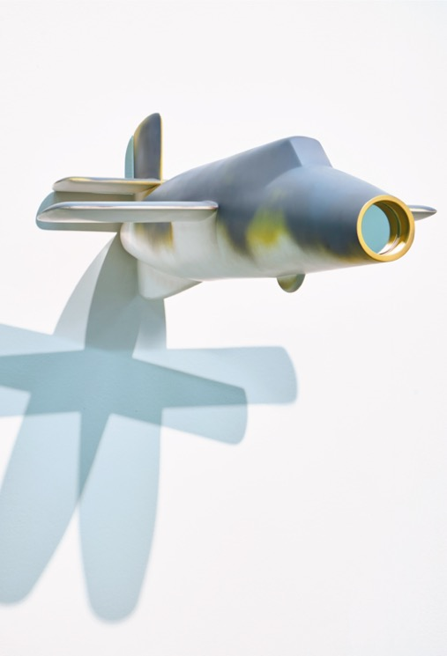

**Maurizio Mochetti**

Aereo-Razzo Bachem Natter BA 349 B-1944 con specchio, 1977

Fiberglass aircraft, mirror

Environmental measurements

35 x 66 x 100 cm aircraft - scale 1:6

***Aereo-Razzo Bachem Natter BA 349 B-1944*** is a model of the vertical take-off rocket plane designed in Germany at the end of the Second World War and never used in wartime actions: a true fetish object, which freed from the constraints of its function is charged with a fascinating allegorical charge.

**Maurizio Mochetti**

*Scala laser 3D*, 1993-2014

3D project: plexiglass cube, high density polystyrene ladder, laser

52 x 50 x 50 cm

*“****Scala laser 3D*** is part of a series of works that I have felt the need to develop since the 1990s, in order to replace the designs that I made as technical drawings, in two-dimensionality, in the 1960s. In this case, I am presenting a model of a staircase that, when a laser is turned on, touches all the steps, marking all the edges with many points of light and creating a hypothetically infinite line that intersects them. This is the design for an environmental work, but the work/idea is already there”. M.M.

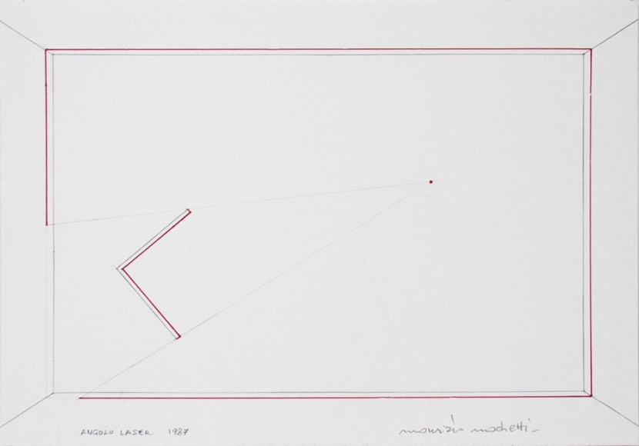

**Maurizio Mochetti**

*Progetto Angolo laser*, 1987

Drawing pencil and felt-tip pen on cardboard

35 x 50 cm

“Since the beginning of my journey, I have given a new value to the project. For me it is not a simple design, but something very important. It is both an initial and preliminary element, a bit like in architecture, but also something more. As early as the 1960s, I found myself wanting to clarify this fundamental concept of the centrality of idea-design-realisation. I did this with my exhibition at Galleria La Salita in 1968 entitled *10 progetti e 2 realizzazioni*”.

***Angolo laser*** it is a blade of light that takes on the geometric shape of the object towards which it is directed. “I am interested in what is created between the obstacle, in this case a corner, and the surrounding space”. M.M.

**Maurizio Mochetti**

*Alle volte in tonneau*, 2013-2016

Plexiglass tube, carbon fibre aircraft, carbon fibre axle, black adhesive

35,5 x Ø 8 cm. Ed. of 29 + 3 AP + IX

Made in 29 examplars + 3 AP + IX, each examplars diverges from the other by a slightly different position of the aircraft on the central axis, which traces the hypothetical trajectory of a scale F-117 Nighthawk aircraft.The aircraft performs a rotation around its longitudinal axis by tracing a spiral around a cylinder (tonneau).

**MAURIZIO NANNUCCI**

Firenze, 1939, where lives and works

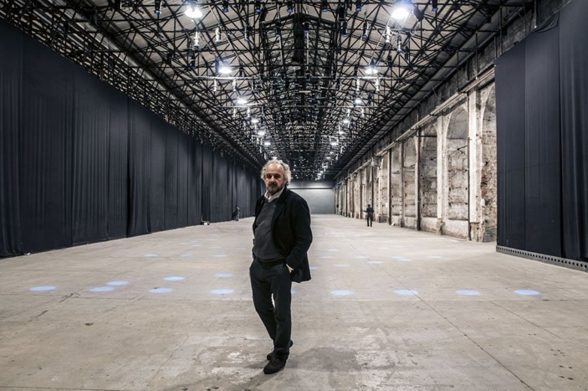

In the first half of the 1960s **Maurizio Nannucci** defines the fundamental elements of his visual research by exploring the relations between art, language and image. At the same time, he established relationships with the artists of the Fluxus movement, became interested in visual poetry and collaborated with the "S 2F M" studio (Studio di Fonologia Musicale in Florence) in the production of electronic music, focusing on the use of voice and words aimed at the production of sound installations. In 1967, for his solo exhibition at Centro Arte Viva in Trieste, Nannucci presented his first texts made with neon lamps, through which he emphasized the temporality of writing and not the materiality of objects. In 1968 he founded the Florentine publishing houses Exempla and Zona Archives Edizioni, both of which published books and catalogues on artists, among them Sol Le Witt, John Armleder, James Lee Byars, Robert Filliou and Ian Hamilton Finlay. Nannucci considers publications and multiples as manifestations of artistic practice where art is treated as a mental process applicable to the mass production of everyday objects in order to reach realms beyond art.

He has shown his work several times at the Venice Biennale, at Kassel Documenta, and at the biennial art shows in San Paolo, Sydney, Istanbul and Valencia.

His works are in the collections of numerous museums around the world, among recent acquisitions *The missing poem is the poem* by Maurizio Nannucci, has become part of MAXXI L'Aquila Museum permanent collection (2021); *New Times for Other Ideas / New Ideas for Other Times* has been installed atCity Life Park in Milan (2020). *New horizons for other visions / new visions for other horizons* has been included in Palazzo Maffei in Verona (2020); Time Past And Time Present Are Both Perhaps Present In Time Future has been installed at the Complesso Monumentale della Pilotta, Parma (2019).

The MAXXI Museum, Rome dedicated to Maurizio Nannucci an important retrospective (2015).

Nannucci took part in several group exhibition at Galleria Enrico Astuni among which *Raccontare un luogo – (Tales of a Place)* (2015); *66|16*, *Ieri, oggi, domani, eccetera…*(2016);  *QUATTRO IDEE* (2021); *La realtà, i linguaggi* (2021).

**Among the works on display in the booth**

**Maurizio Nannucci**

*Love***,** 1987

Neon in blue, red, yellow, and green Murano glass

250 x250 cm

Maurizio Nannucci began using neon in 1967, pursuing research on language begun in the early 1960s. The proposed phrases often remain unresolved, between thought and action, illuminating the moment of power in which everything can still happen; everything is yet to be constructed.

*Love* conceptually shifts the viewer's attention from the physical place to a mental place by inviting through the reading of its words to remember and desire – thus also introducing the dimension of remembrance and dreaming.

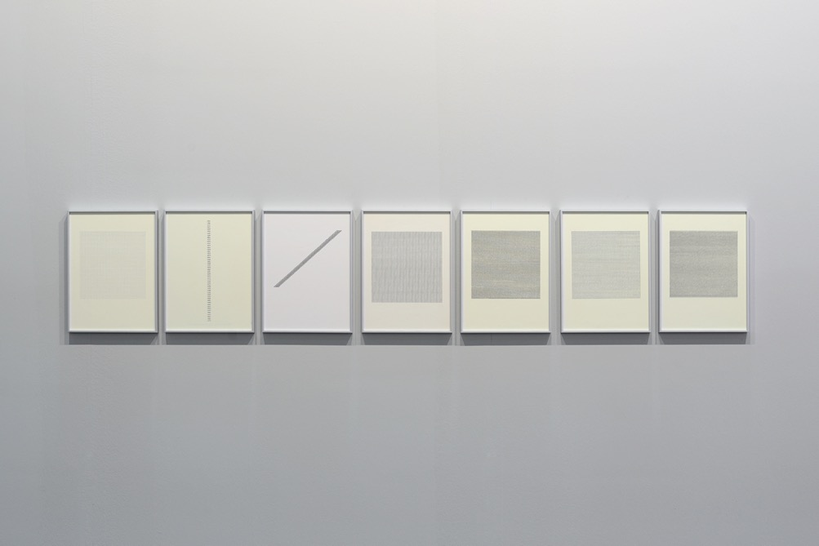

**Maurizio Nannucci**

Dattilogrammi, 1964-1965

Dactylogram

30 x 22 cm (each)

The ***Dattilogrammi*** series, 1964-65, was made using an Olivetti machine, where Nannucci investigates the word as pure geometric form, in its linear or minimal specificity. "In 1964, I made the first *Dattilogrammi,* a cycle that would last a couple of years, with a small Olivetti Lettera 22, which was my mind-machine, my media, my creative tool; together with the sheet of white or colored paper, the privileged support on which a word or a sign was to be structured as a pure geometric form, in its linear and minimal specificity" (M.N.).

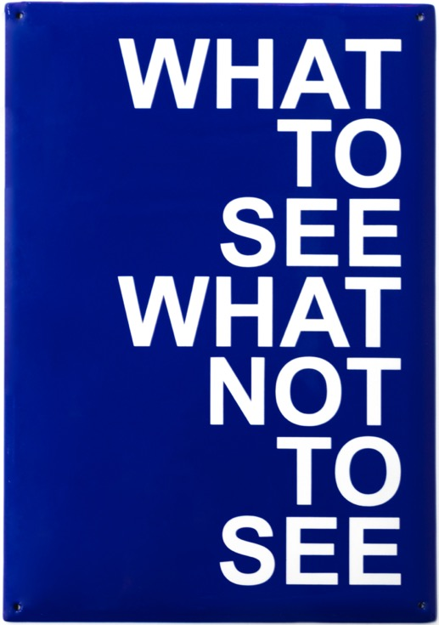

**Maurizio Nannucci**

*What to see what not to see*, 2021

Press-curved metal sheet, porcelain enamel, text with airbrush paint, glossy finish

214 x 149 x 2,5 mm. Ed. of 29 + 5 AP

What to see what not to see, what to say what not to say… what to hear… what to feel… what to love…Maurizio Nannucci poses a series of questions that make us to reflect on the condition of man in society in a dual relationship, with others and with himself. The urgency that arises daily is to make a choice: what to see, what to say, what to think, what to perceive, what to love... how to orient our decisions. Nannucci's aim is not to offer solutions but to indicate and allude to the different possibilities of reading and interpreting the signs that surround us, in a continuous opening and declination of semantic components.

Behind the passion for multiples and artists' books there is the attempt to shape an artistic practice that develops itself as a mental process and strips the art object of its uniqueness giving to it new possibilities, also and above all outside the museum or gallery institution. However, the value of the multiple is certainly not limited to its function as a 'free art object' but each project brings with it an agile, entertaining, aesthetically, and poetically valuable idea.

**GIANNI PIACENTINO**

Coazze (Torino) 1945. Lives and works in Turin

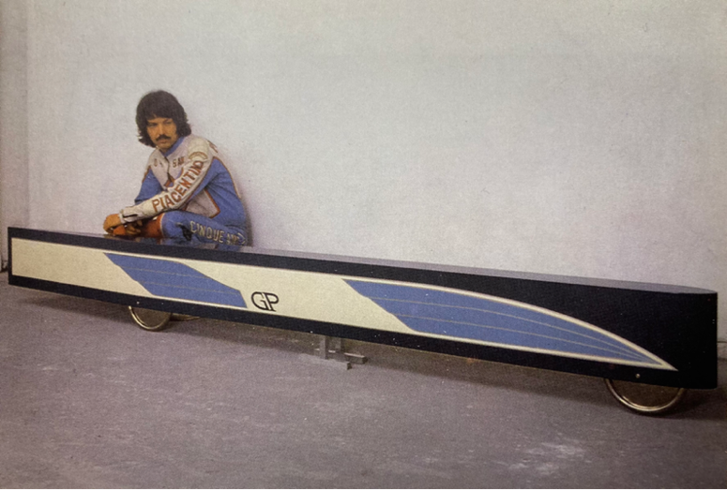

**Gianni Piacentino’s** work turns out to be a unique case on the Italian and international scene.

A figure of great relevance by virtue of the originality of his vision, Piacentino made his debut in the mid-1960s by making vehicle prototypes out of industrial materials, sculptures with essential geometric shapes made out of plasticized and painted wood, and developing, in parallel, an original idea of painting. "Gianni Piacentino's work is for many reasons unclassifiable. Although it resonates with themes and ideas that characterised the international artistic debate of the neo-avant-gardes, his work stands as a profoundly singular experience. (...) Over the course of his long career, Piacentino developed an original and coherent language, defining, articulating, and enriching the set of intuitions he arrived at between 1965 and 1970, the years in which his poetics took definitive shape. Always rejecting the logic of groups and movements, he affirmed the possibility - and I would even say the necessity - of the existence of the individual, outside the masses and perhaps even outside his own time." Andrea Bellini. His works are in the permanent collections of many museums such as GAM Galleria d'Arte Moderna in Turin, Madre Museum in Naples, Power Institute of Fine Arts in Sidney, National Galerie in Berlin, Neuen Museum Weserburg in Breme and MAMCO Genève in Geneva.

**Among the works on display in the booth**

**Gianni Piacentino**

*RACE 18 (V.H.S.),* 1991-2002

Various materials

68 x 380 x 16,1 cm

“Towards the end of the 1960s, Piacentino made his first vehicles: those works ended up confirming the distance separating him from the artists with whom he had exhibited in the Arte Povera years, attested by the attention to detail: the “finish fetish” as American critics used to say at that time, in relation to West Coast artists, and then the importance of design”. (Andrea Bellini).

“For Piacentino everything here is long and thin, each sculpture is a fuselage designed to better cut through an imaginary wind (...) At first sight his sculptures are bathed in a cold light. But the chill of the industrial object is only apparent: it is contradicted by that retro air, that nostalgia for a future already past with which his style is imbued. The same one that emanates from the paintings dedicated to the Wright brothers' epic and seaplanes, the same one imprinted in the logos with his initials "GP" and in the Empire or 20th-century style friezes reproduced like a trademark on each sculpture in place of the signature”. (Gregorio Botta).

**Gianni Piacentino**

DYNAMIC TECH-BAR, B2, 2009

Water-base enamel (2K acrylic matt clear) on aluminum, resin and iron, polished aluminum (anticorodal)

19 x 224 x 9,8 cm

"One recurring element is the grille (how many of these will you see before long in electric cars that, no longer needing the radiator, play aesthetically on the front grille). I started making them in the early 1990s, maybe in '91, even with the pantograph engraver, it was very expensive to drill the panels. Now with CAD and the milling cutter it's very quick. I have also been working on grids for ages, I don't know if I had already started making them when I saw Roy Lichtenstein's paintings. He used industrial grids, with a round hole. I had the first ones specially made. There are wall bars from '91, I think, the first ones with the grid. Now that the industrial ones exist, the work is imagined differently'. (G.P.)

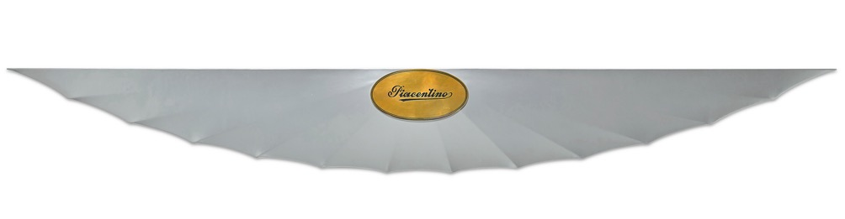

**Gianni Piacentino**

*Pearl Wall Wing with Signed Golden Plate II*, 1971

Nitro enamel on gold-plated brass and polyester-coated painted canvas applied on wood

43 x 340 x 5,5 cm

***Pearl Wall Wing with Signed Golden Plate II***, created in 1971, is an early, spectacular version of his typical 'wings', consisting of a wooden frame onto which is affixed a canvas painted with a splendid pearlescent, iridescent varnish.

"Colour is another one of Piacentino's obsessions; it may appear to be a simple industrial enamel, but it is instead the result of mixtures - always different - carefully chosen by the artist. And indeed, in titles of his works, colour is always mentioned: blue-light pearl, purple-grey, pink-cream, amaranth-dark and so on. (For each of them the artist keeps a tab and a sample for eventual restoration)” (Gregorio Botta)

**Gianni Piacentino**

*TROPHY (Model ’91)*, 2021

Acrylic enamel (2K), nitro-acrylic enamel on resin, aluminum alloy (Anticorodal 6082)

140 x 8,7 x 8 cm

*TROPHY* is the decorative wall declination of Gianni Piacentino's 1986 *RECORD VEHICLE* and symbol of speed in competition, which the artist knows very well from his sidecar racing past. It was created in 1991 in large dimensions (270 cm, 4 different versions in terms of colour and decoration).

In 1991-92 it was produced as TROPHY MODEL (128 cm, 11 different versions by colour and decoration) and in 2004 as TROPHY Ms1 (160 cm, 10 different versions by colour and decoration). ***TROPHY (Model '91),*** 2021 was made for the Enrico Astuni Gallery in 4 colour variants.

Each variant of *Trophy (Model '91)* is stored in a beautiful wooden case, specially created to contain it.